Functional dependencies are

DEP_NUM 🡪 DEP_NAME

ADVISOR_NUM 🡪 ADVISOR_FIRST_NAME, ADVISOR_LAST_NAME, DEP_NUM

COURSE_CODE 🡪 DESCRIPTION

STUDENT_NUM 🡪 STUDENT_FIRST_NAME, STUDENT_LAST_NAME, ADVISOR_NUM

STUDENT_NUM, COURSE_CODE 🡪 GRADE

E-R Diagram

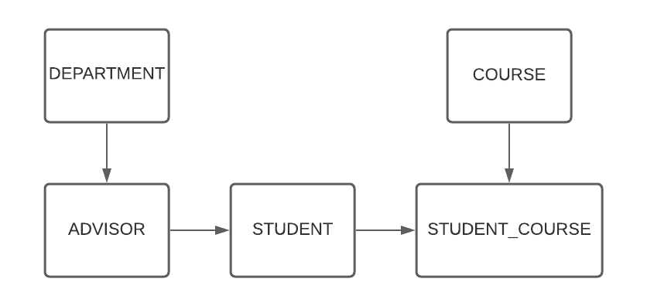

Tables with primary keys/composite keys underlined.

DEPARTMENT(DEP_NUM, DEP_NAME)

ADVISOR(ADVISOR_NUM, ADVISOR_LAST_NAME, ADVISOR_ FIRST_NAME, DEP_NUM)

STUDENT(STUDENT_NUM, STUDENT_LAST_NAME, STUDENT_FIRST_NAME, ADVISOR_NUM)

COURSE(COURSE_CODE, DESCRIPTION)

STUDENT_COURSE(STUDENT_NUM, COURSE_CODE, GRADE)

For the next part it would be the same tables since its already in third normal form

DEPARTMENT(DEP_NUM, DEP_NAME)

ADVISOR(ADVISOR_NUM, ADVISOR_LAST_NAME, ADVISOR_ FIRST_NAME, DEP_NUM)

STUDENT(STUDENT_NUM, STUDENT_LAST_NAME, STUDENT_FIRST_NAME, ADVISOR_NUM)

COURSE(COURSE_CODE, DESCRIPTION)

STUDENT_COURSE(STUDENT_NUM, COURSE_CODE, GRADE)